**Task 6**

**Performance check for the module of urbanladder using Jmeter on AWS cloud**

Launch Jemter and select recording template and do the required configuration

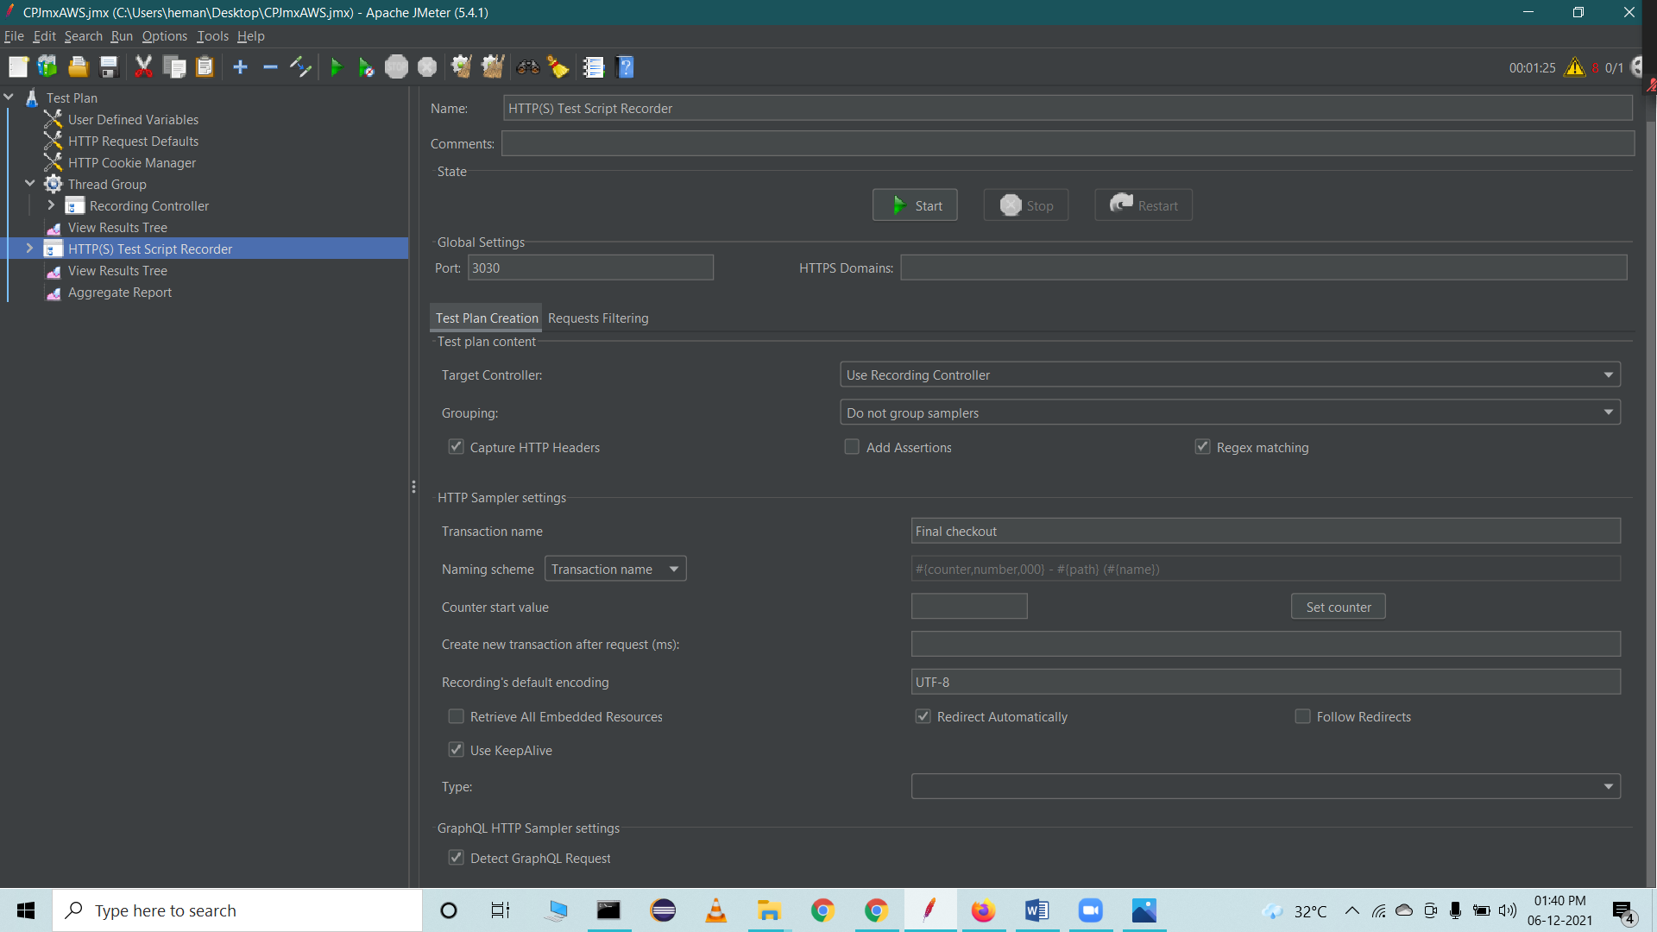

Start recording to capture the Http requests that we perform on the webpage ([www.urbanladder.com](http://www.urbanladder.com))

We performed multiple operations in the webpages of that website and recorded are all Http request events from launching to checkout section

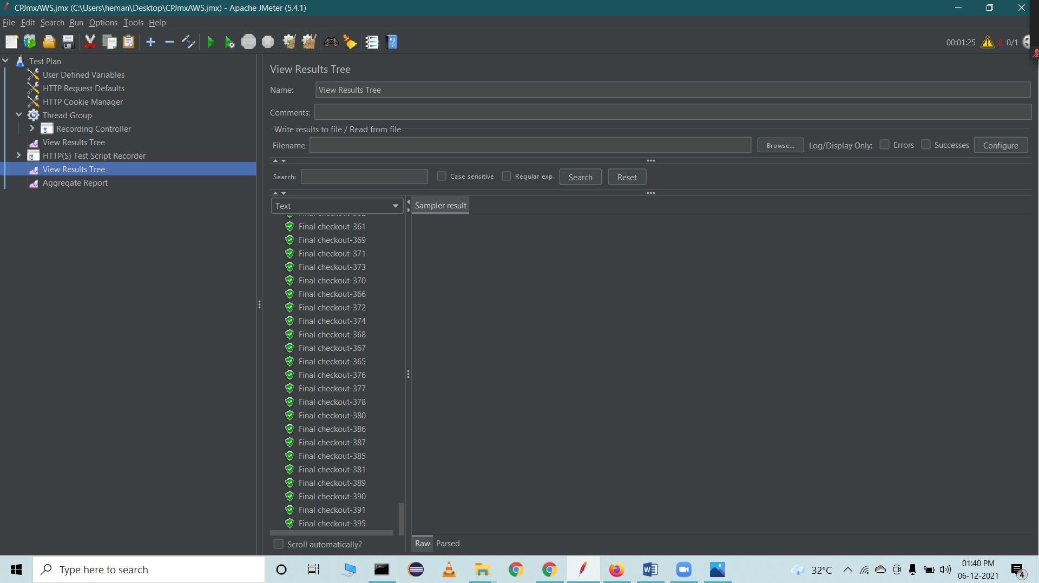

Save the Jmx file and use it in AWS cloudfromation template to perform load testing

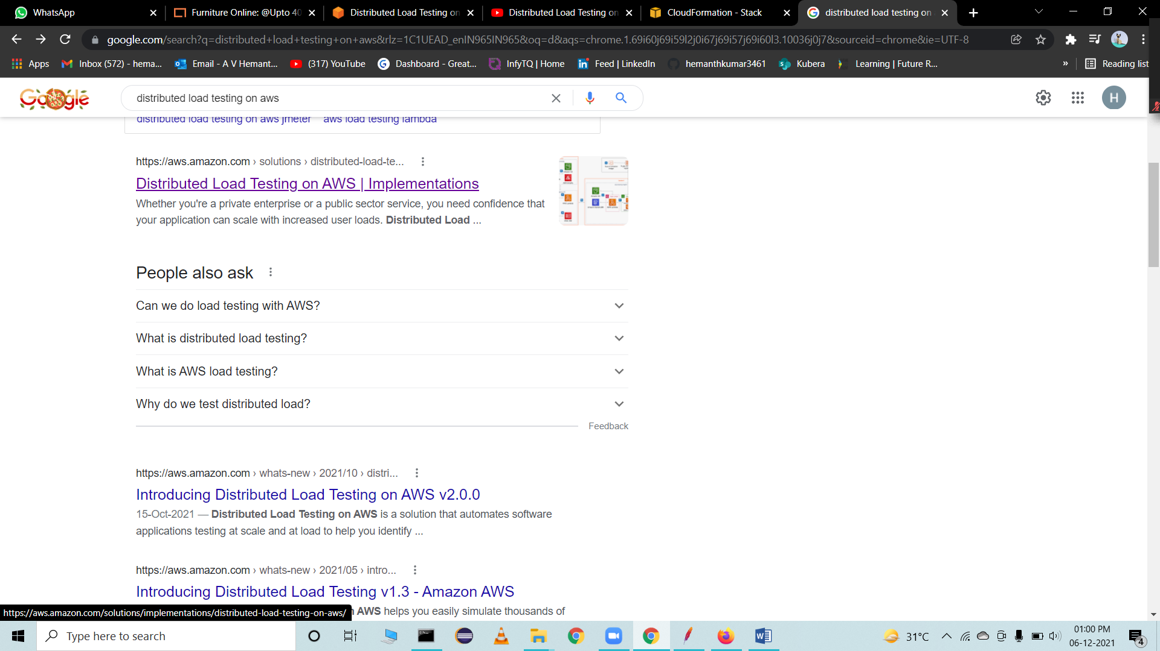

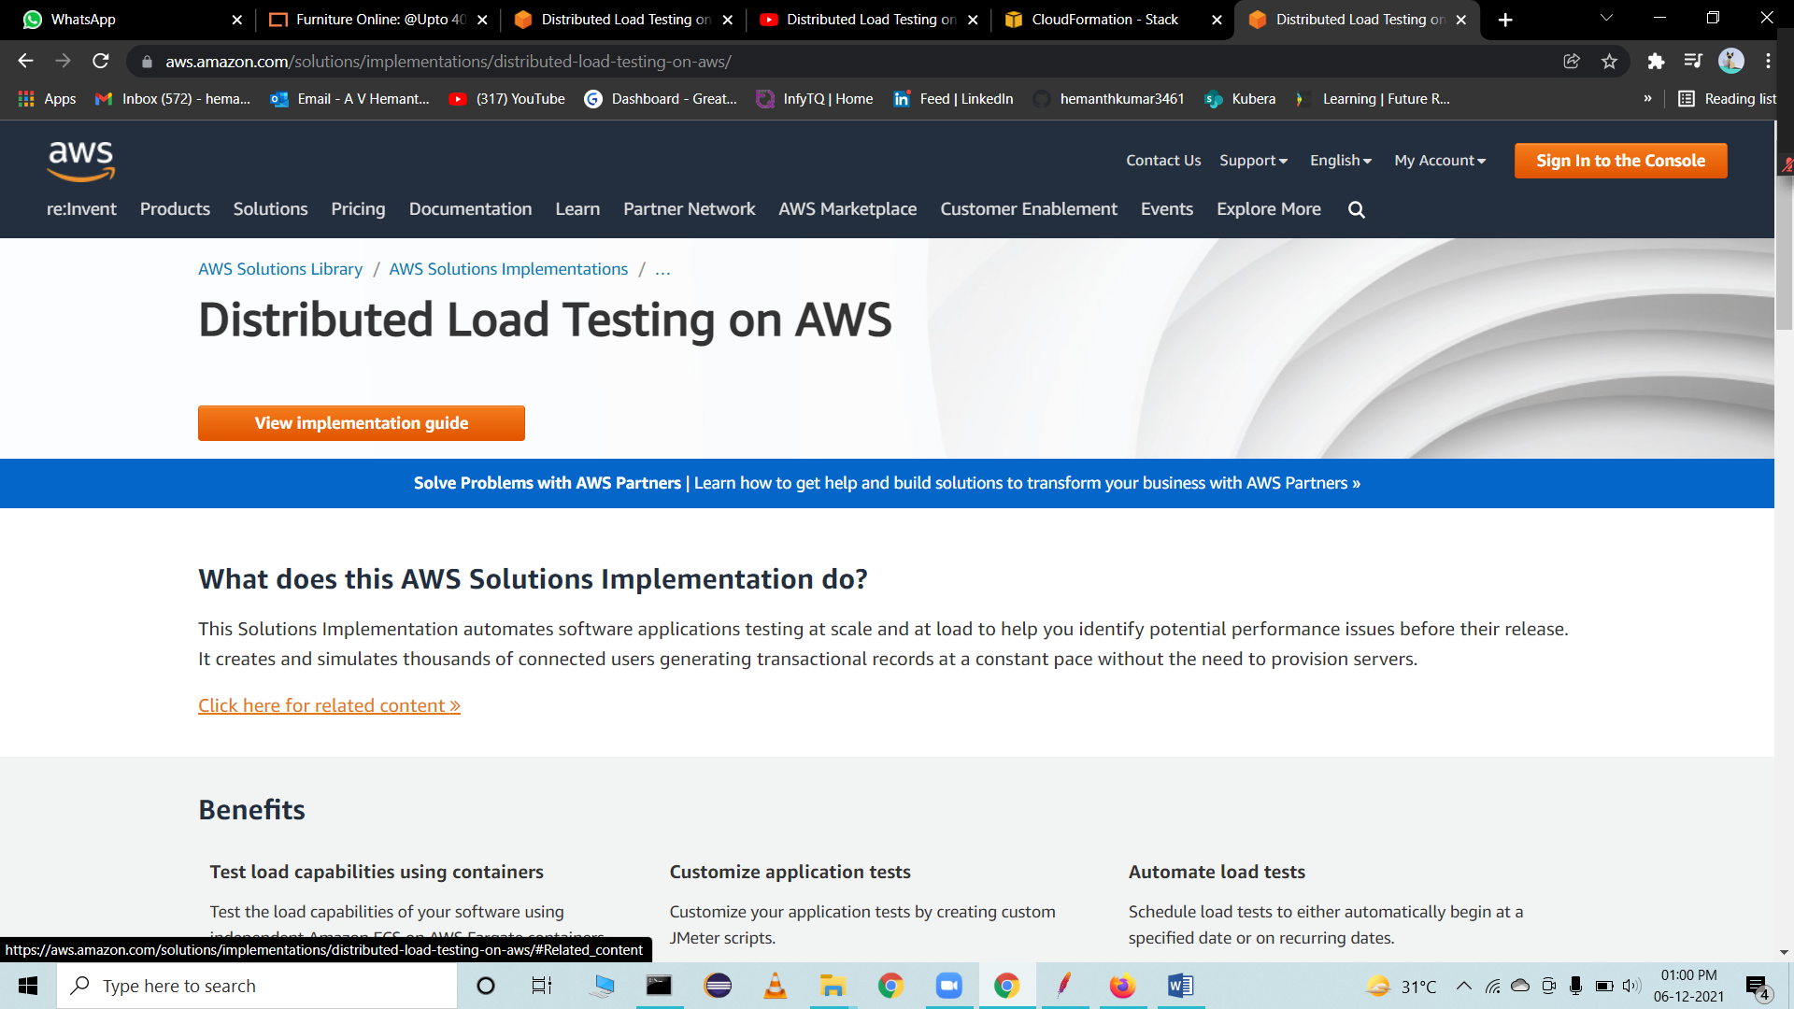

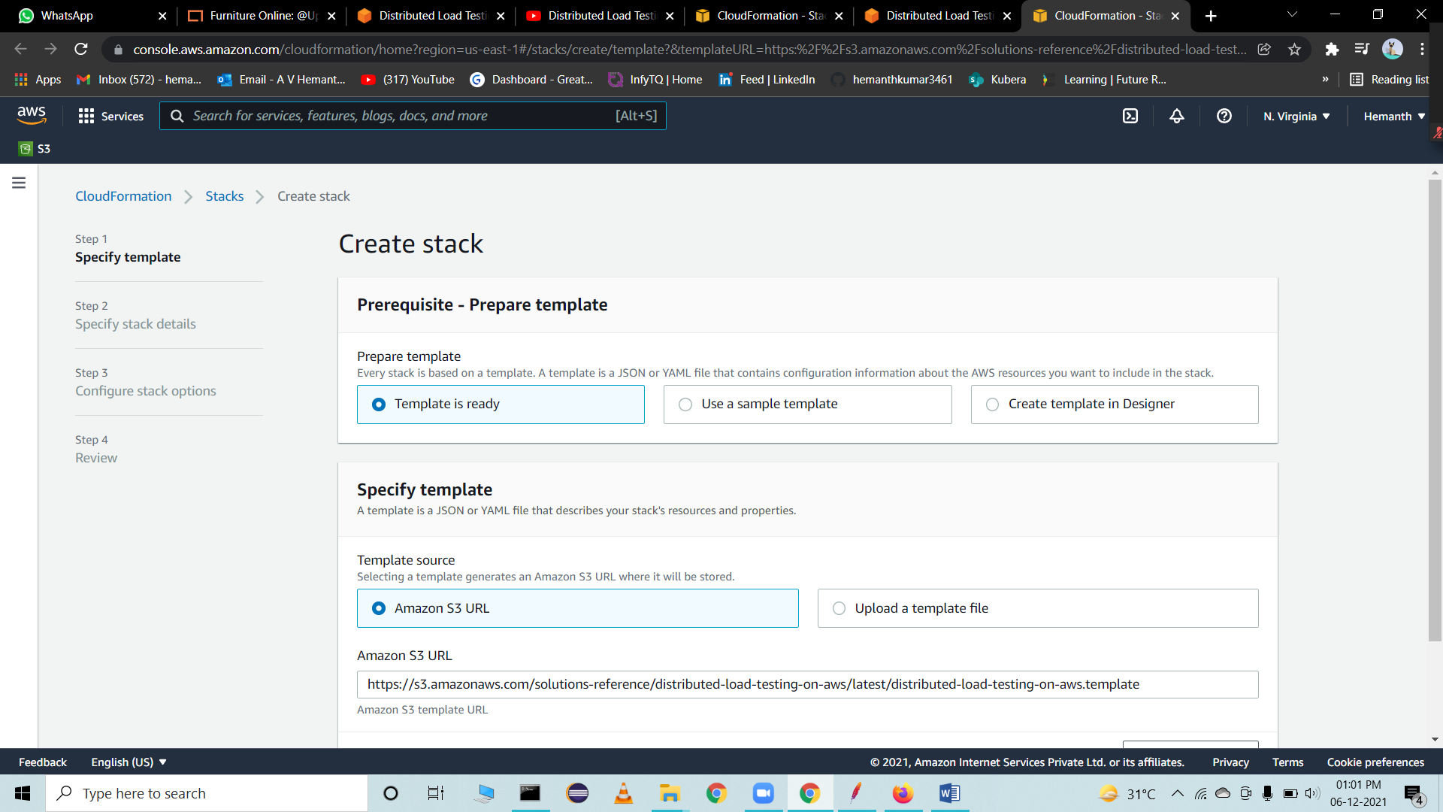

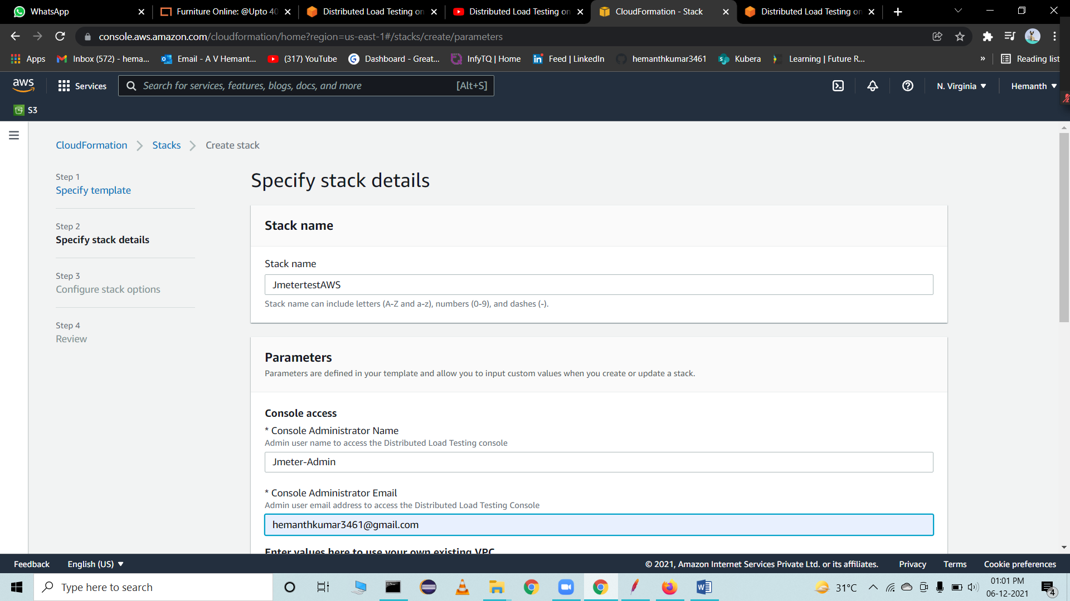

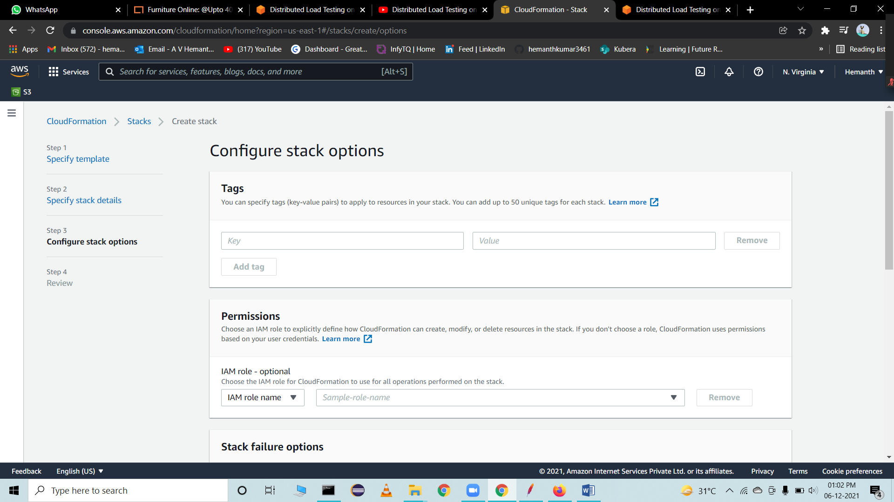

Provide all the default setup and click on create stack



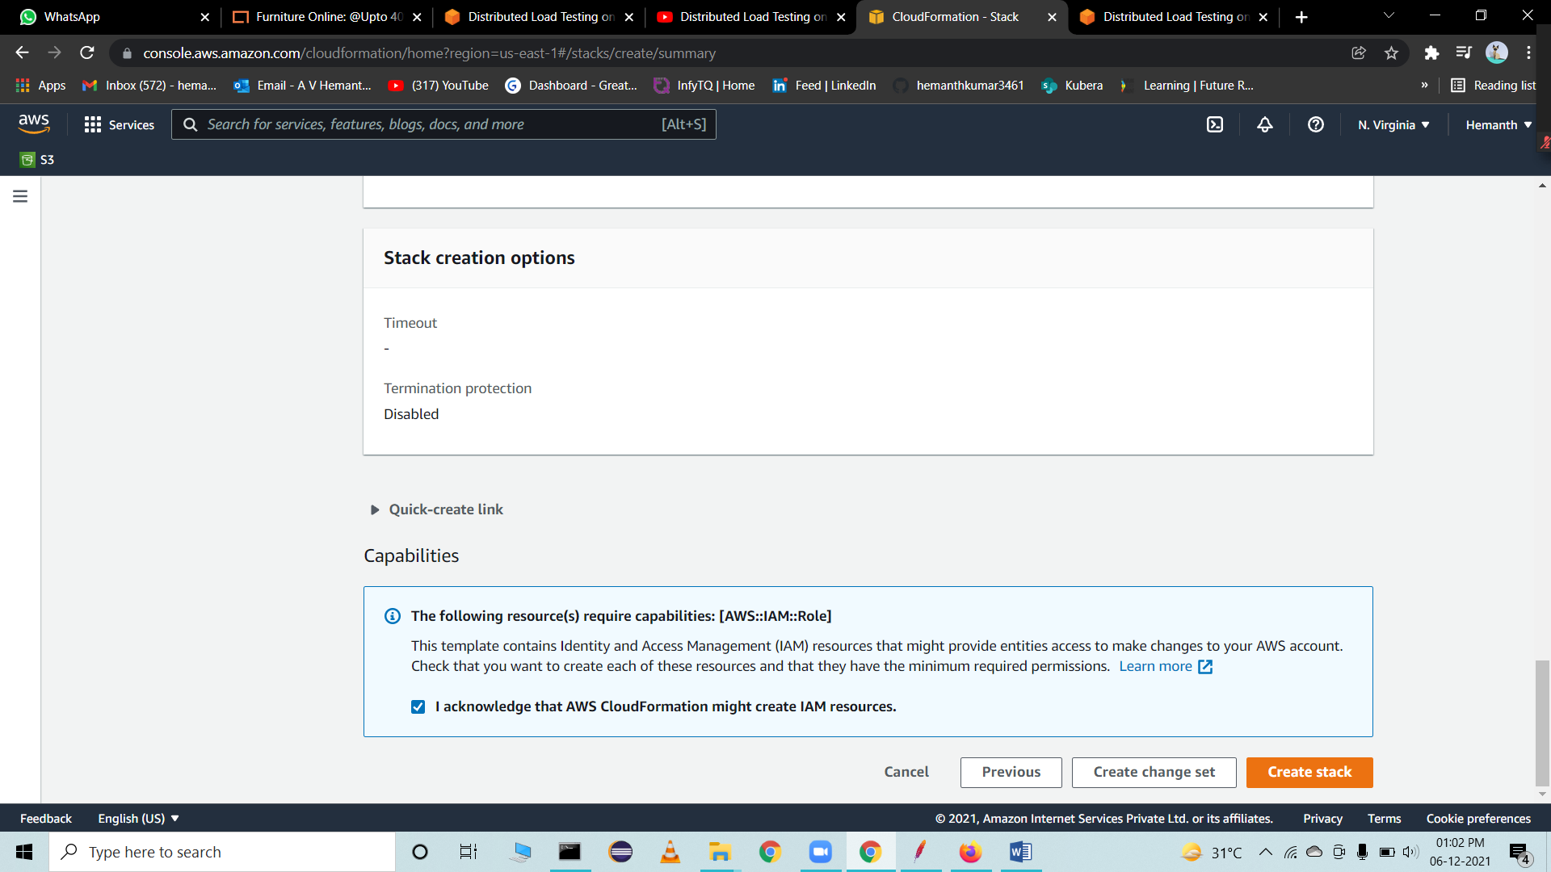

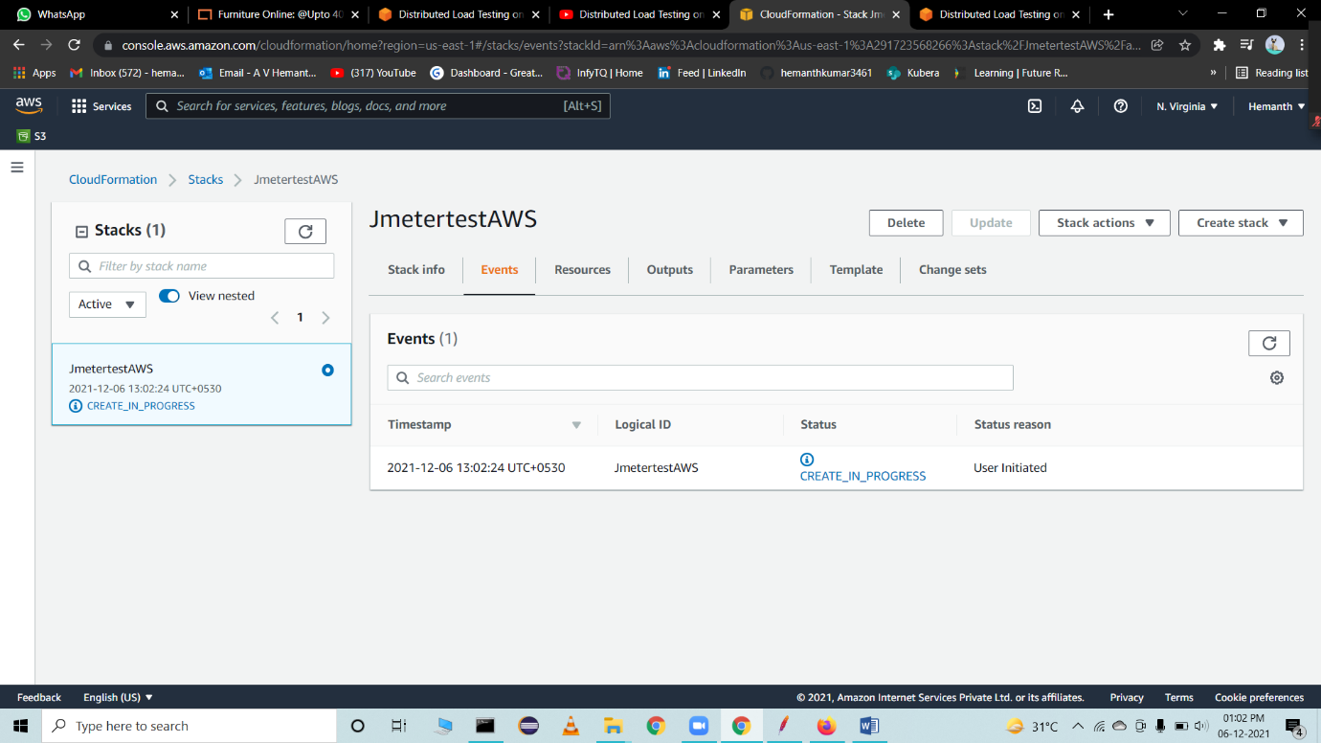

The process of creating this stack takes around 15 min

Once its created, you will receive the Url, Username and Password to the provided mail ID.

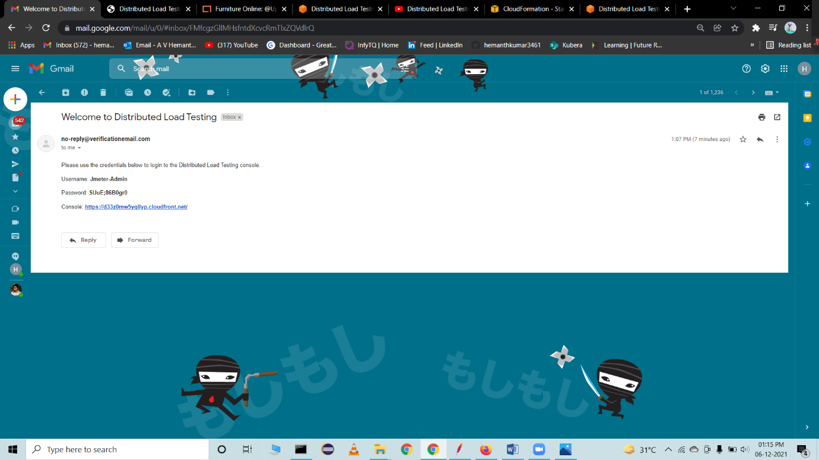

On-Click URL

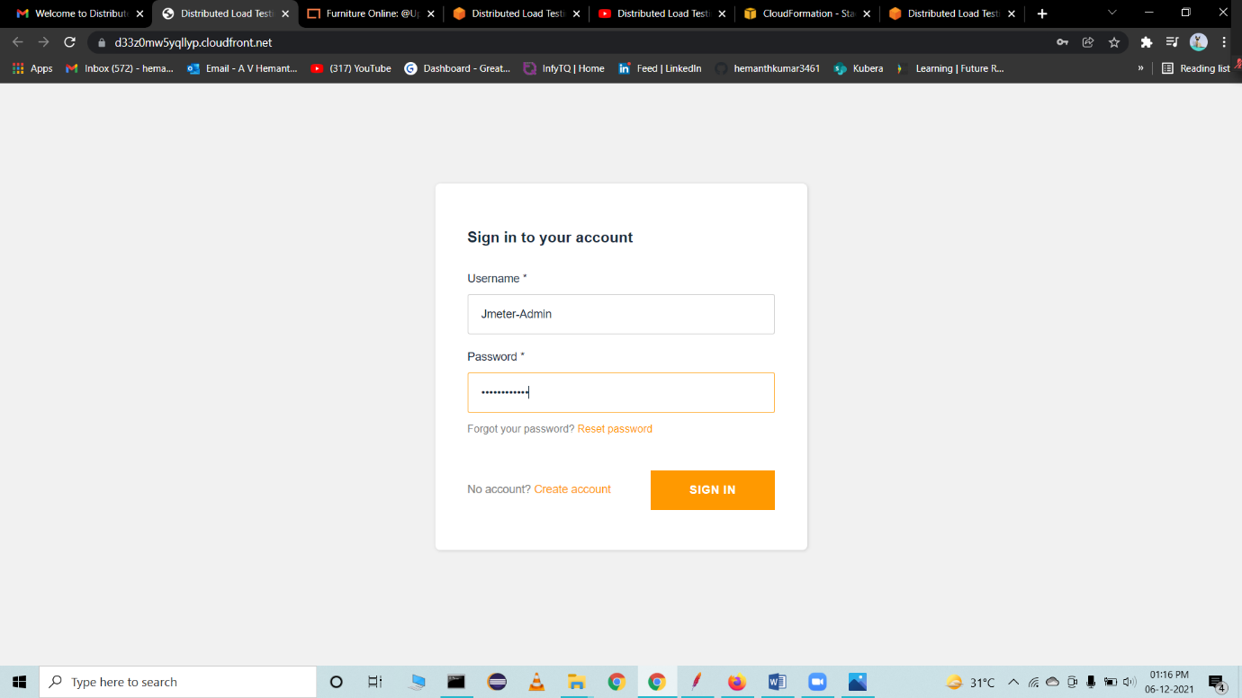

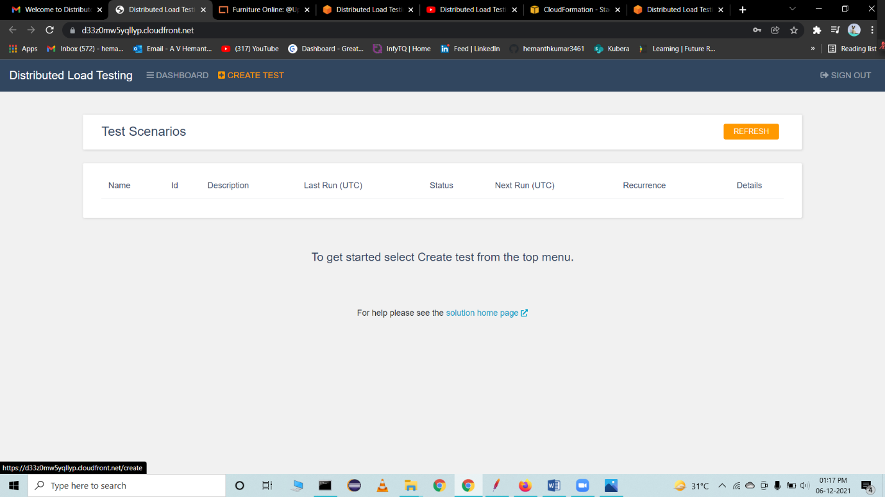

Here, we can create our test and configure the setup like number of dockers, Users etc.

